

Semester One Examination, 2016

Question/Answer Booklet

MATHEMATICS
APPLICATIONS
UNIT 3

Section One:

Calculator-free

Name

Teacher

Time allowed for this section
Reading time before commencing work: five minutes
Working time for section: fifty minutes

Materials required/recommended for this section
To be provided by the supervisor
This Question/Answer Booklet
Formula Sheet

To be provided by the candidate
Standard items: pens (blue/black preferred), pencils (including coloured), sharpener, correction fluid/tape, eraser, ruler, highlighters

Special items: nil

Important note to candidates
No other items may be taken into the examination room. It is your responsibility to ensure that you do not have any unauthorised notes or other items of a non-personal nature in the examination room. If you have any unauthorised material with you, hand it to the supervisor before reading any further.

Structure of this paper

Section | Number of questions available | Number of questions to be answered | Working  time (minutes) | Marks available | Percentage of exam
Section One:  Calculator-free | 7 | 7 | 50 | 50 | 35
Section Two:  Calculator-assumed | 12 | 12 | 100 | 100 | 65
 |  |  | Total | 150 | 100

Instructions to candidates

- The rules for the conduct of examinations are detailed in the school handbook. Sitting this examination implies that you agree to abide by these rules.

- Write your answers in this Question/Answer Booklet.

- You must be careful to confine your response to the specific question asked and to follow any instructions that are specified to a particular question.

- Spare pages are included at the end of this booklet. They can be used for planning your responses and/or as additional space if required to continue an answer.
- Planning: If you use the spare pages for planning, indicate this clearly at the top of the page.
- Continuing an answer: If you need to use the space to continue an answer, indicate in the original answer space where the answer is continued, i.e. give the page number. Fill in the number of the question that you are continuing to answer at the top of the page.

- Show all your working clearly. Your working should be in sufficient detail to allow your answers to be checked readily and for marks to be awarded for reasoning. Incorrect answers given without supporting reasoning cannot be allocated any marks. For any question or part question worth more than two marks, valid working or justification is required to receive full marks. If you repeat any question, ensure that you cancel the answer you do not wish to have marked.

- It is recommended that you do not use pencil, except in diagrams.

- The Formula Sheet is not to be handed in with your Question/Answer Booklet.

Section One: Calculator-free 35% (50 Marks)
This section has seven (7) questions. Answer all questions. Write your answers in the spaces provided.

Working time for this section is 50 minutes.

Question 1 (7 marks)
(a) Re-draw the following graph to clearly demonstrate that it is planar. (3 marks)

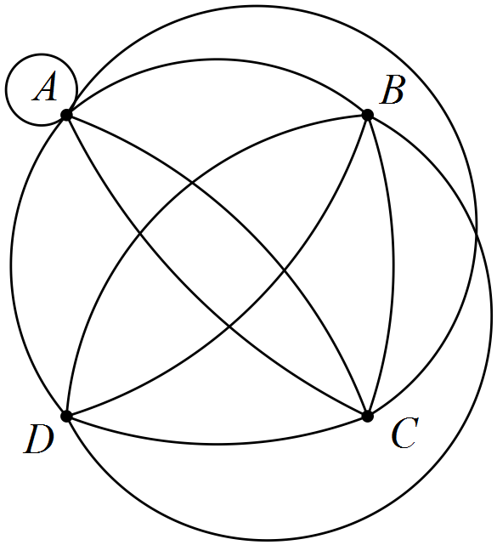

(b) Draw a complete graph with five vertices. (2 marks)

(c) Do all complete graphs obey Euler's formula? Justify your answer. (2 marks)

Question 2 (8 marks)
The scatterplot below, with least-squares line displayed, shows the relationship between two numerical variables, x and y. The correlation coefficient between the variables is 0.92.

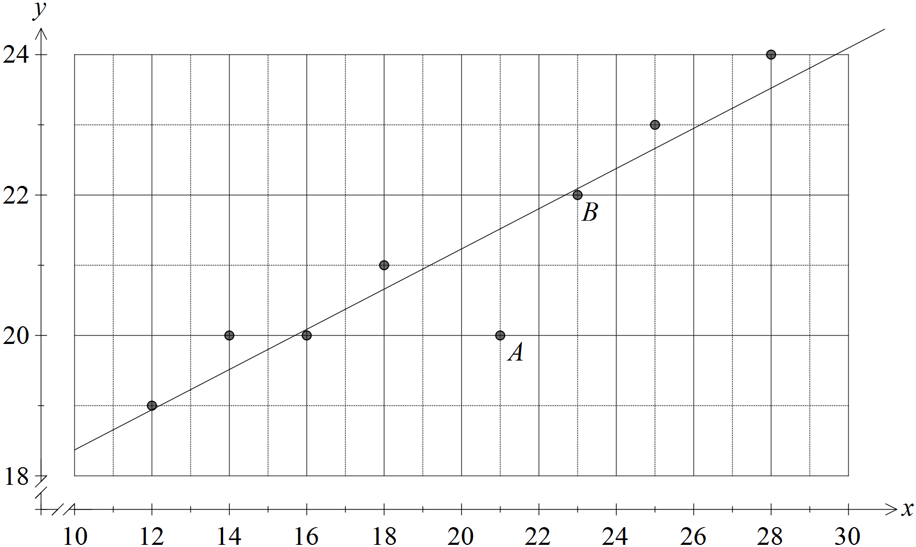

(a) Describe the association between x and y in terms of direction and strength.
(2 marks)

(b) Describe the effect on the correlation coefficient if

(i) the point labelled A was removed from the dataset. (1 mark)

(ii) the point labelled B was removed from the dataset. (1 mark)

(c) Sketch a residual plot for the eight paired values on the axes below. (3 marks)

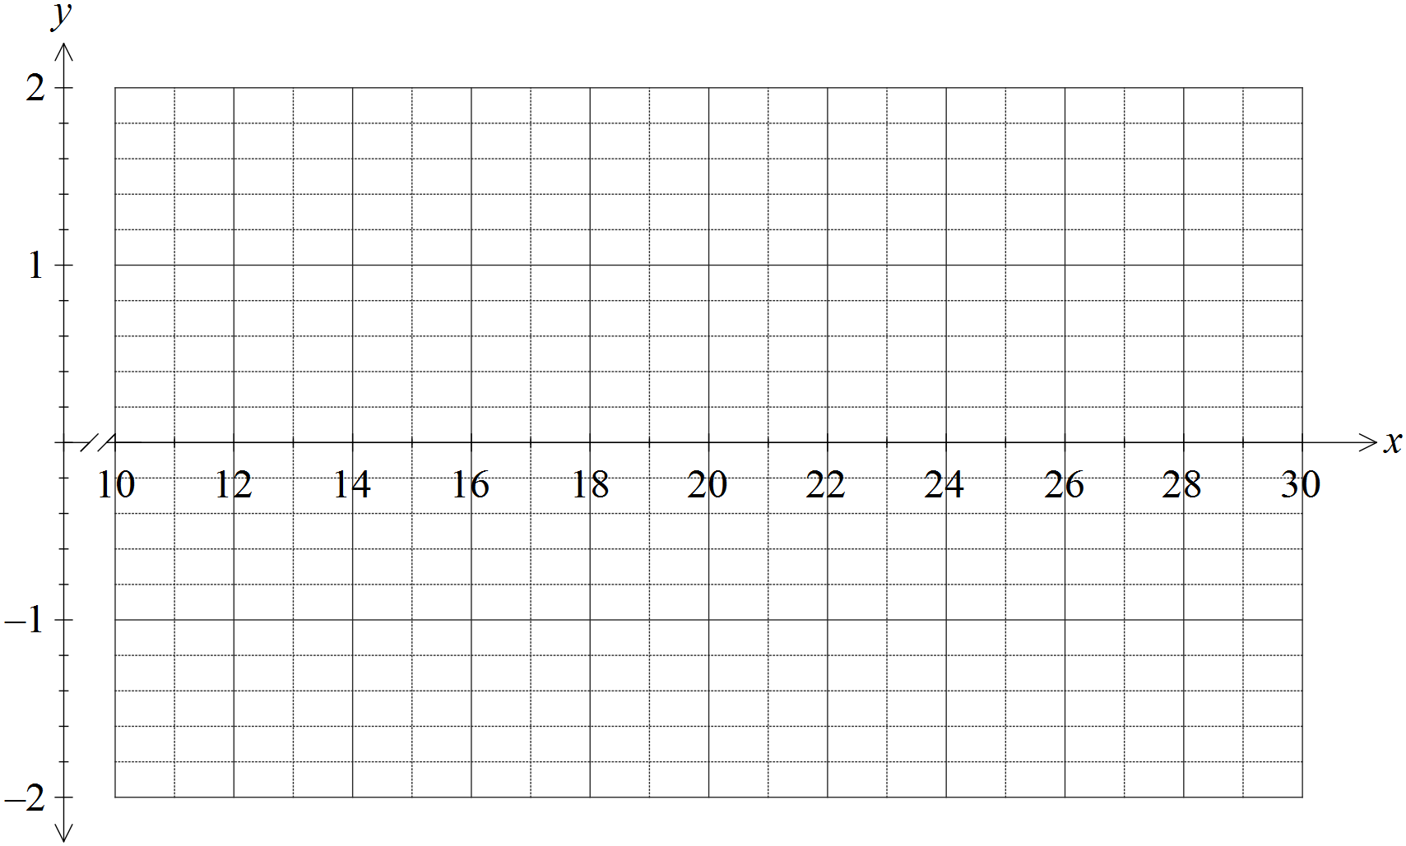

(d) Comment, with reasons, on the appropriateness of fitting a linear model to this dataset.
(1 mark)

Question 3 (6 marks)
(a) Three hikers were sharing tips about walking on four famous routes. Ahn had walked the Inca Trail, Kilimanjaro and the Snowman Trek. Bi had walked the Inca Trail, Kilimanjaro and the Overland Track. Chris had walked the Overland Track and the Snowman Trek.

Display this information as a bipartite graph. (2 marks)

(b) A bipartite graph is shown below, joining vertices in two disjoint sets. Clearly list the vertices belonging to each of the two sets. (2 marks)

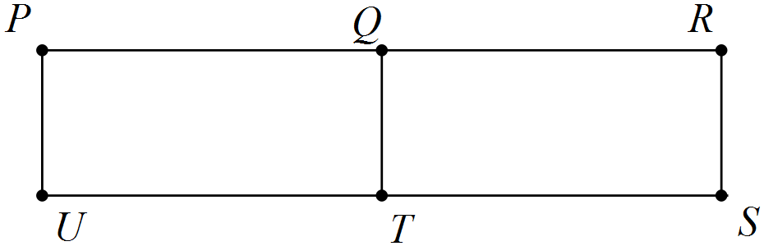

(c) A complete bipartite graph has six vertices. Determine the smallest possible number of edges. (2 marks)

Question 4 (8 marks)
The terms of a sequence are shown in the graph below.

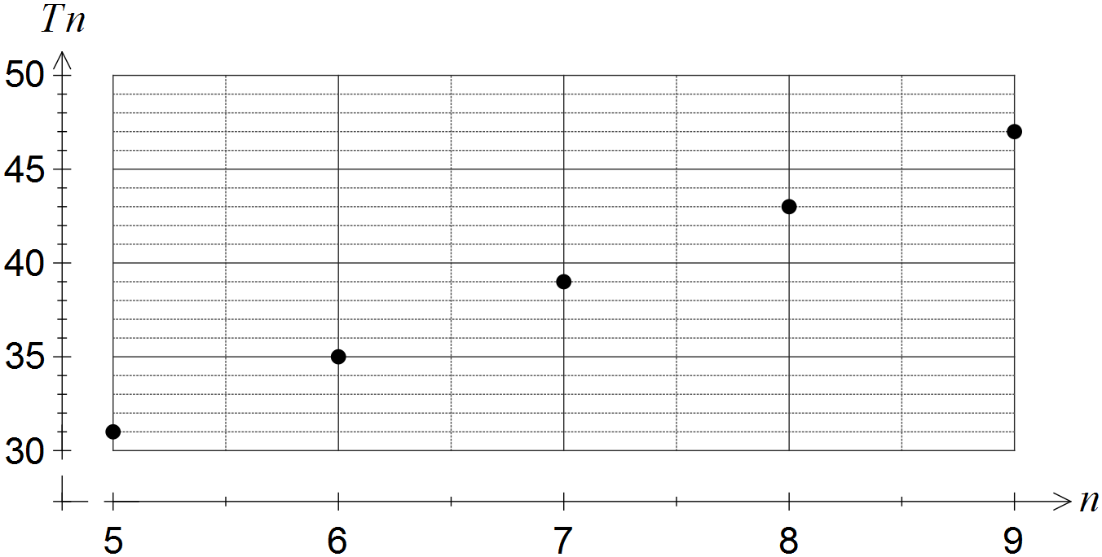

(a) Choose the best description of the sequence from geometric, arithmetic or neither, explaining your choice. (2 marks)

(b) Determine

(i) . (1 mark)

(ii) . (1 mark)

(c) Deduce a rule for the n^{th} term of the sequence, simplifying your answer. (2 marks)

(d) Determine the value of n such that . (2 marks)

Question 5 (7 marks)
The edges in the graph below represent the roads in a park that meet at the given vertices.

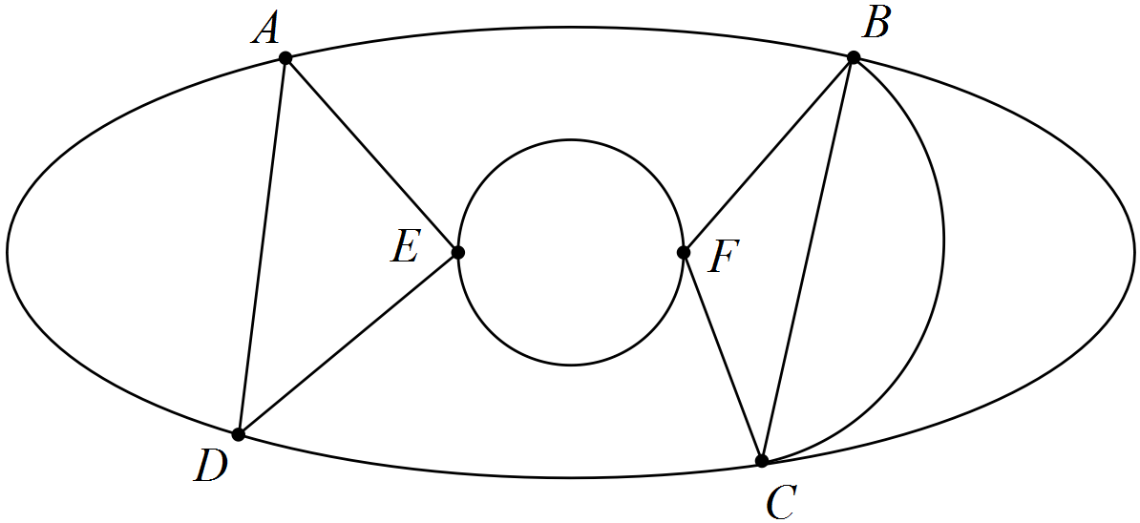

(a) Show that Euler's formula applies to this graph. (2 marks)

(b) Record the degree of each vertex shown in the graph in the table below. (2 marks)

Vertex | A | B | C | D | E | F
Degree

(c) State a path that shows the graph is semi-Eulerian. (2 marks)

(d) A park ranger has to inspect every road in the park. List all possible starting points so that the ranger can complete this task without driving on the same road more than once.
(1 mark)

Question 6 (5 marks)
The scatterplot below shows data from a sample of towns in a region.

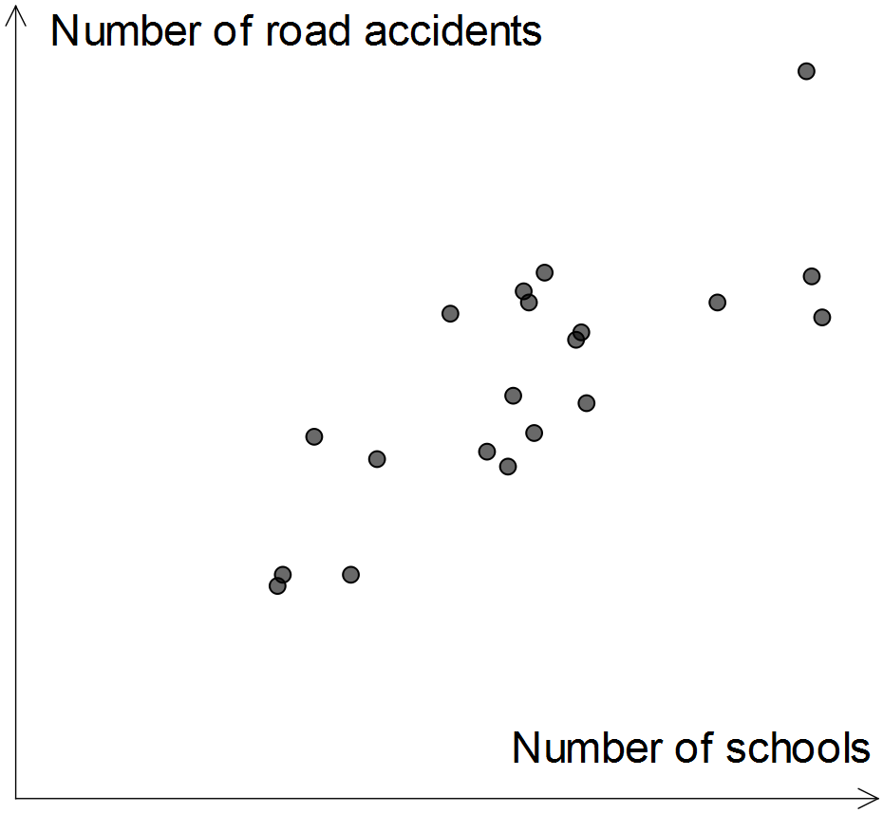

(a) Which of the numbers 1, -1, 0.75, -0.75, 0.5, -0.5, 0.25, -0.25 and 0 is closest to the correlation coefficient between the two variables? Explain your choice. (2 marks)

(b) A politician saw the graph and claimed the data supported his plan to merge small schools and hence reduce the number of schools in individual towns. Identify a reason the politician might have had to make such a claim. (1 mark)

(c) Identify and explain a possible non-causal explanation for the observed association between the number of schools and the number of road accidents in this sample of towns. (2 marks)

Question 7 (9 marks)
(a) A connected planar graph has one face and three edges.

(i) Determine the number of vertices the graph has. (2 marks)

(ii) Sketch a graph with these properties. (2 marks)

(b) Consider the graph below.

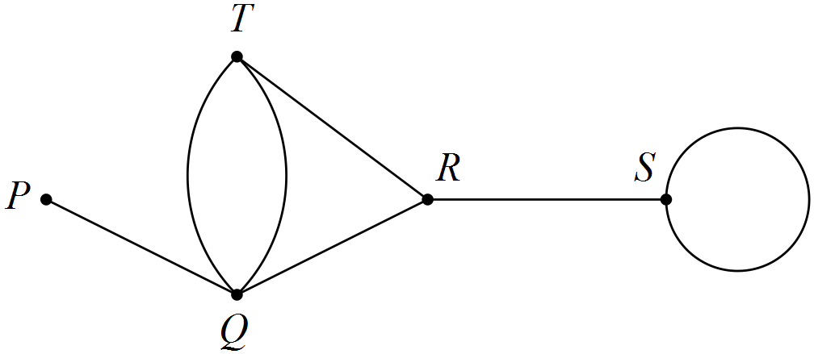

State the length of the longest possible walk in this graph and list, in order from first to last, the vertices visited, so that the walk

(i) is an open trail. (2 marks)

(ii) is a closed path. (3 marks)

Additional working space

Question number: _________

© 2016 WA Exam Papers. Kennedy Baptist College has a non-exclusive licence to copy and communicate this paper for non-commercial, educational use within the school. No other copying, communication or use is permitted without the express written permission of WA Exam Papers.

